ESE516 SCHEMATIC REVIEW (A3)

|  |  |
| --- | --- |
| **Review Team** | NikhilSheil |
| Teammember A | Nikhil Jamdade |
| Teammember B | Sheil Sarda |
| Reviewer | Eduardo Garcia |
| Date | Feb 24 2019 |
| Project File | ESE516_ExampleBaseProject_V2.PrjPcb (Feb 22, 2019) |

**Main Schematic**

**•** Good idea on connecting the BQ Enable and SYSOFF to the MCU Pins. However, for safety I recommend adding pulldowns or pullups depending on the default setting you want. I recommend putting a 10k pulldown on each of lines (BQ_SYSOFF, BQ_EN1, BQ_EN2). I also recommend removing the inline jumpers – they are now needed in this case.

* VUSB are not connected – was your intention to use an external supply just in case? In general, use Power ports for power nets.  
  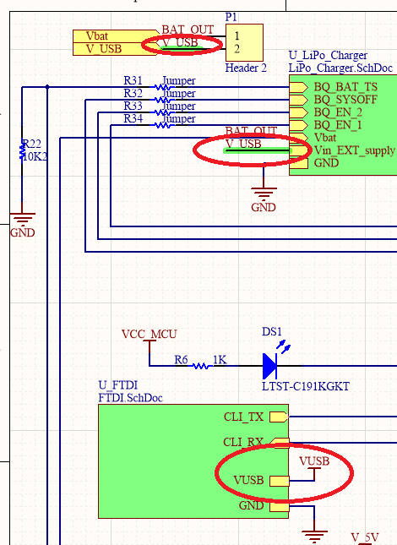
* For the battery connector, please add its own connector with VBAT and GND.
* Critical: The buzzer needs a square wave, make sure the pin you chose can do a PWM output. Also, you need to add a BJT to handle the current – see the datasheet. The MCU cannot provide the current needed directly from the pins.  
  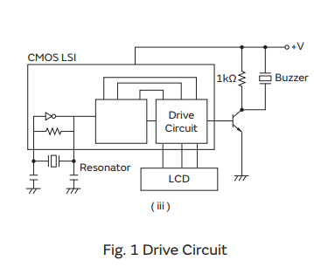
* Resistor R21 is not doing anything  
  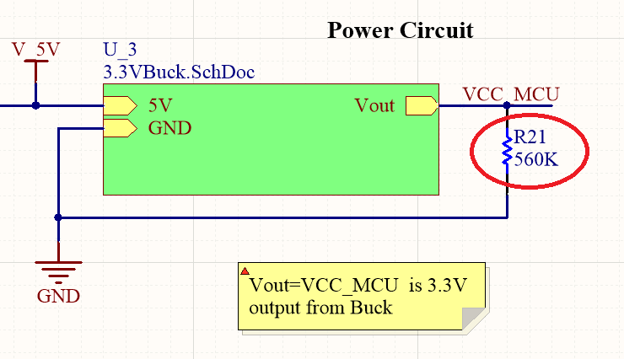
* Please add ERC to pins not used.
* Add testpoints for I2C lines and INT lines as well as servo PWM and feedback.

**LiPo Fuel Gauge Schematic**

* Please add a ground port to make the schematic clearer.
* Please change the designator of the device from Fuel Gauge to U? where the ? is an unique number in your design.
* This IC has no associated footprint. Please make and add the respective footprint.
* Please add the MPN. I cannot review without it.
* Critical: Device is wrong! Pin numbers are incorrect. Please double check with datasheet and update the device to have the correct pinout.
* Critical: The schematic is wrong! Please follow section 10.2 of the datasheet: <http://www.ti.com/lit/ds/symlink/bq27441-g1.pdf>

**5V BOOST**

* Critical - TPS61230DRCR needs a feedback resistor divider – please see the datasheet. HOWEVER, if you meant to use the TPS61232DRC, which is the fixed 5V output, then you can leave FB connected, but you have to change the component to be TPS61232DRC.

**3V3 BUCK**

* Component has some issues:
  + **Critical:** Component is wrong! Pins are incorrect. Please redo part and check datasheet Section 5: <http://www.ti.com/lit/ds/symlink/tlv62568a.pdf>
  + **Critical: Feedback resistors are missing. Please check datasheet Section 5:** [**http://www.ti.com/lit/ds/symlink/tlv62568a.pdf**](http://www.ti.com/lit/ds/symlink/tlv62568a.pdf)

**IR Thermometer**

* Component has no associated footprint

• Please change the designator of the device to U? where the ? is an unique number in your design**.**

* **Add MPN to device. I am assuming it is the MLX90614ESF-BAA-000-TU**

**Servo Motor Schematic**

* **Component has no footprint. Please associate a footprint.**

**Thermal Camera Schematic**

* Component is missing pin names and footprint. Fortunately the AMG8833 component is available on Altium Vault – please consider using that one, or fix your existing component.
* Please check the schematic with <https://learn.adafruit.com/assets/43011> . R36 is doing nothing – if you want to have the option of selecting high or low, put a jumper between the AD_Select pin and ground.

**MCU Schematic**

pin checkout

SERCOM 1 is for SPI for WINC

SERCOM 4 is for UART CLI

SERCOM 3 for IR I2C – PA17 SCL, PA22 SDA

SERCOM 0 for Thermal and fuel gauge – PA08 SDA, PA09 SCL

ADC A0 PA02 for analog input

PA24: TC5/WO[0] OR TCC1/ WO[2]

* Critical: PA09 is connected as if it were SDA but Atmel Start tells me it is SCL. SAME FOR PA08. Please double check and fix!
* Critical: The analog of the SAMD21 must be from 0V to VCCA/2 (which is 1.65V). You will need to use a voltage divider to scale the ADC input from the servo. Also, the net label should read SERVO_ADC, not SERVO_DAC
* I recommend adding a button and an extra LED for debugging purposes or for system on/off.
* Please connect pin 10 to GND.

**General Comments**

Please review ALL the components that were made by hand. They have missing footprints and the symbols are wrong. Refer to the tutorial we did in class for steps on how to do this.

Add an external connector for the battery only (positive and negative terminal).

I recommend to implement the fixes and pair review the schematic.

**Grade:**

Component: -40 points: There are multiple component issues that if they made it to manufacturing would make the board not work. Please pair review the components you make with the datasheet, as it is easy to miss mistakes. Also, make sure footprints are associated with component.

Schematic Errors: -25 points: There are some errors that could have been caught if you double check the layout with the datasheet (which is something I recommend you to always do). It is easy to make mistakes while wiring schematics.

Grade: 235/300